**For more information, contact:**

Dan Danford, 262-636-7359

[dan.danford@caseih.com](mailto:dan.danford@caseih.com)

Claire Haupt, 262-424-6143

chaupt@bader-rutter.com

**Case IH Introduces Real-time Remote Dashboard With AFS Connect™ 2.0**



*Unique ‘Terms of Use’ Keeps Agronomic Data in Producers’ Control*

RACINE, Wis. Aug. 26, 2014

Case IH has announced its new AFS Connect 2.0™, a new farm management system that uses advanced telematics technology to help producers effectively monitor and manage their operations without compromising control of their data. The system, which will be fully available in 2015, provides a simple, intuitive view of machine location and diagnostics, with maintenance and service alerts — even allowing for two-way messaging with machine operators from anywhere.

AFS Connect 2.0 will offer more features and functionality than competitive products in a system with a straightforward and easy-to-use design. In addition, Case IH has taken special measure to offer what some may consider the most important feature — data control.

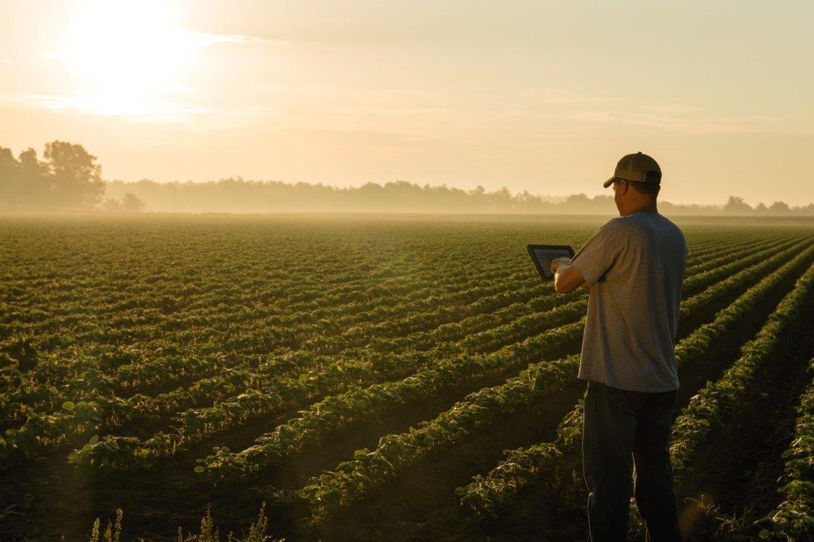

Caption: Case IH has announced its new AFS Connect 2.0**™**, a new farm management system that uses advanced telematics technology to help producers effectively monitor and manage their operations without compromising control of their data.

Photo credit: Case IH

Click [[HERE]](http://www.caseih.com/en_us/PressRoom/Pages/Media-Library.aspx) to download a hi-res file.

“Case IH understands the growing importance of data security and privacy,” said Mike Klein, Advanced Farming Systems North America Marketing Manager, Case IH. “It is important to ensure the *producer* has complete control over who accesses his agronomic and equipment data. Each producer has the option to allow his dealer or others to view information, but bottom line, the choice is theirs. We’ve written it right into our terms-of-use agreement.”

Case IH is a founding member of the [Open Ag Data Alliance](http://openag.io/) (OADA), an organization designed to bring security and privacy to agricultural data. Case IH firmly believes in the central guiding principle of OADA, which states that “each farmer owns data generated or entered by the farmer, their employees or machines performing activities on their farm.”

AFS Connect 2.0 not only works on different types of equipment but also can be the unifying factor to monitor, control and manage critical data for operations with mixed fleets. Live Time provides the user of AFS Connect 2.0 with a real-time view of what is happening on the machine. It provides a reliable, consistent, one-minute data update rate, with 30 minutes of Live Time on the dashboard and 30 additional minutes of Live Time through the CAN Viewer, which gives you a deeper dive into machine performance data — per modem, per day — for second-by-second remote training and diagnostics.

Users also can send messages from the Web portal to the AFS Pro 700 control center with a predetermined set of answers for the operator to easily select. And it’s all accessible through a simple-to-use browser interface via desktop, laptop, tablet or other remote device.

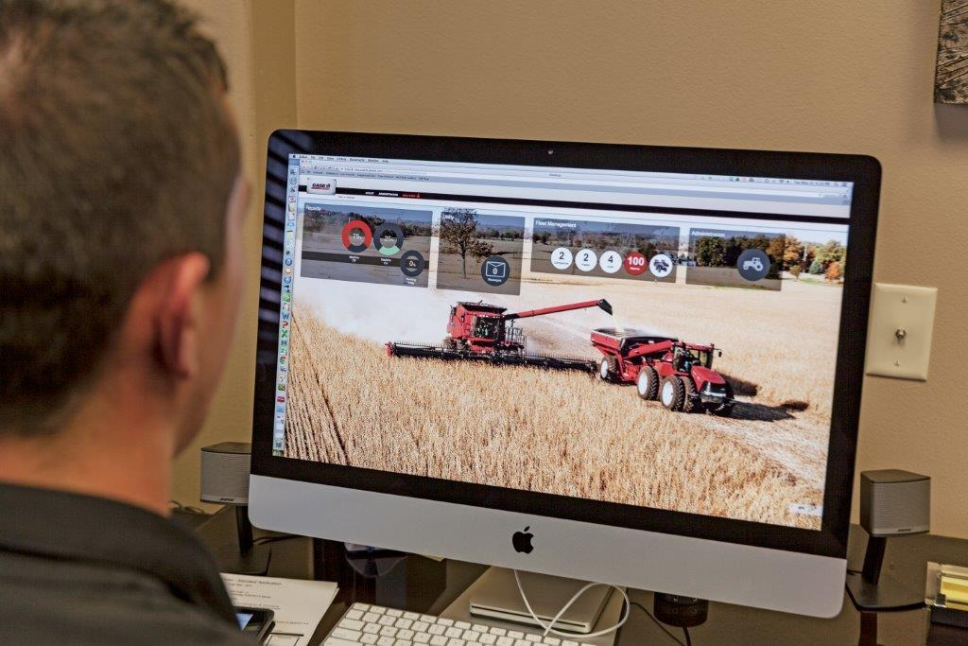  
Caption: AFS Connect 2.0 not only works on different types of equipment but also can be the unifying factor to monitor, control and manage critical data for operations with mixed fleets.  
  
Photo credit: Case IH  
  
Click [[HERE]](http://www.caseih.com/en_us/PressRoom/Pages/Media-Library.aspx) to download a hi-res file.

AFS Connect 2.0 has a wide range of features, including:

* Industry-leading, easy-to-use live dashboard with user-friendly graphics of key vehicle parameters
* Ability to send messages from the Web portal to the AFS Pro 700
* Wireless data transfer
* One-minute update rate, which is unmatched in the industry
* Industry-leading Live Time streaming of the dashboard for up to 30 minutes per day per modem to support live troubleshooting and performance tuning
* CAN Viewer on the portal, providing real-time visibility of the machine parameters for up to 30 minutes per day per modem (in addition to dashboard Live Time)
* Machine monitoring, including machine status, customizable geofence monitor and motion detection
* Fleet management, including vehicle mapping and historic breadcrumbing

“In addition to the team of AFS certified dealers and Case IH precision farming specialists   
Case IH has a 24/7/365 support network to answer producers’ questions and needs,” Klein said. “Case IH understands not everything happens during the day, so this commitment keeps producers rolling every day, every hour, everywhere.”

For more information about AFS Connect 2.0, contact your local Case IH dealer or visit [CaseIH.Com/AFSConnect](http://www.caseih.com/en_us/AFS/Pages/AFSConnect.aspx).

Case IH is a global leader in agricultural equipment, committed to collaborating with its customers to develop the most powerful, productive, reliable equipment — designed to meet today’s agricultural challenges. With headquarters in the United States, Case IH has a network of dealers and distributors that operates in over 160 countries. Case IH provides agricultural equipment systems, flexible financial service offerings and parts and service support for professional farmers and commercial operators through a dedicated network of professional dealers and distributors. Productivity-enhancing products include tractors; combines and harvesters; hay and forage equipment; tillage tools; planting and seeding systems; sprayers and applicators; site-specific farming tools; and utility vehicles. Case IH is a brand of CNH Industrial N.V. (NYSE: CNHI / MI: CNHI).

###